Error enter a number at the start Failure 1 but it loops.

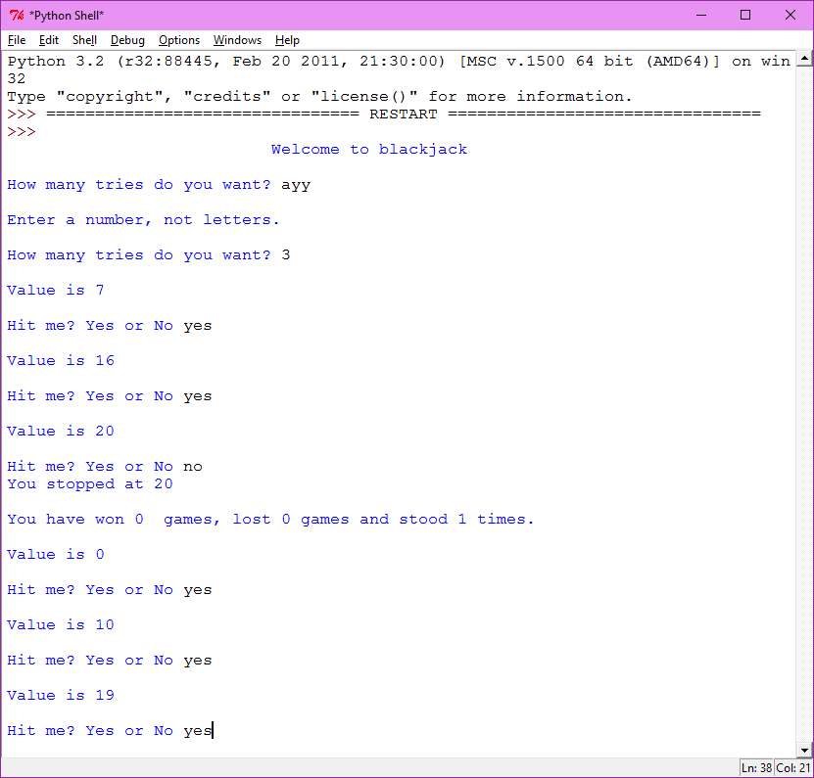

Working1

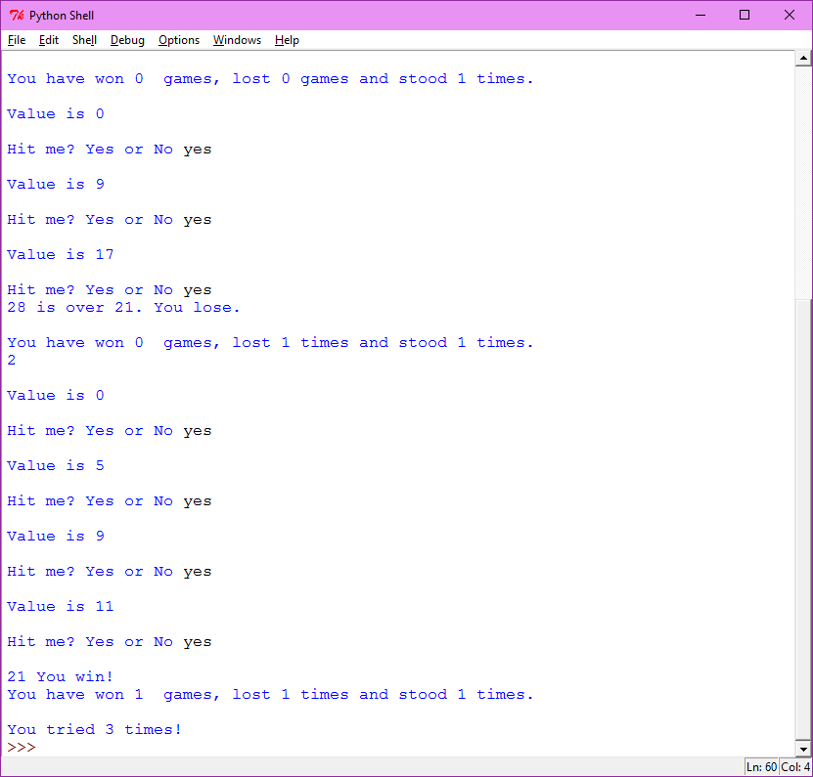

Working 2

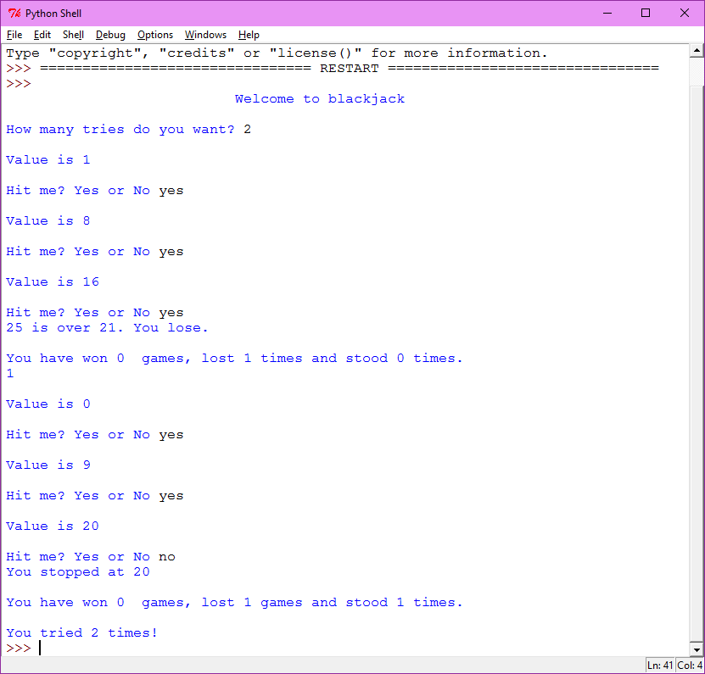

#Sally Kyvernitis

#9/20/2015

#blackjack game using loops

import random

print(format("Welcome to blackjack", '^75s')) # centered

print()

#all variables

stand=0

wins=0

loss=0

tries=0

count=1

value=random.randint(1,11)

everything = stand + wins + loss

tf=True

#while true, how many tries, if tries greater than or = to 1, then false.

while(tf):

try:

tries=input("How many tries do you want? ")

tries=int(tries)

if tries >= 1:

tf=False

else:

print("Enter a number")

except:

print()

print("Enter a number, not letters.")

print()

#try block containting while loop.

try:

while value < 21 and everything != tries: #while the value is under 21 and everything isnt equal to tries.

print ()

print ("Value is",value)

print ()

askuser=input("Hit me? Yes or No ")

askuser=askuser.upper()

askuser=askuser.strip()

#yes will promt a hit

if askuser == "YES":

value = value + random.randint(1,11)

if value > 21:

print(value,"is over 21. You lose.")

loss = loss + 1

print()

print("You have won", wins," games, lost", loss, "times and stood", stand,"times.")

value=0

everything = everything + 1

print(everything)

count=count+1

#value equal to 21 will equal a win.

if value == 21:

wins = wins + 1

print()

print (value, "You win!")

print("You have won", wins," games, lost", loss, "times and stood", stand,"times.")

value=0

everything = everything + 1

count=count+1

#no will stop a hit. And add a stand.

if askuser == "NO":

stand=stand+1

print ("You stopped at", value)

value = 21

print()

print("You have won", wins," games, lost", loss, "games and stood", stand,"times.")

value=0

everything = everything + 1

count=count+1

#everything equaling tries will end the program

if everything == tries:

print()

print("You tried " + str(tries) + " times!")

#this will print error message and tell user to type a number.

except Exception as error:

print("You need to type a number.")

tf=False

print(error)